**Name: PARMESH YADAV**

**Roll No: 2020319**

**SCIENTIFIC COMPUTING (MTH373)**

**HOMEWORK – 3**

Problem – 1

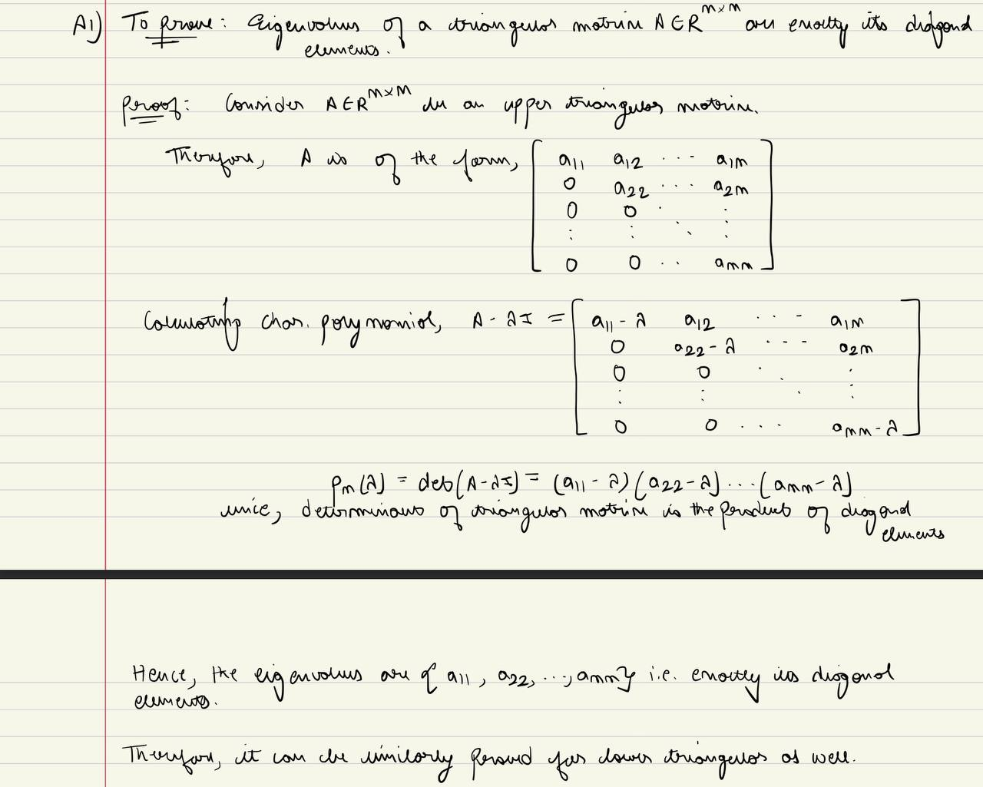

Problem – 2

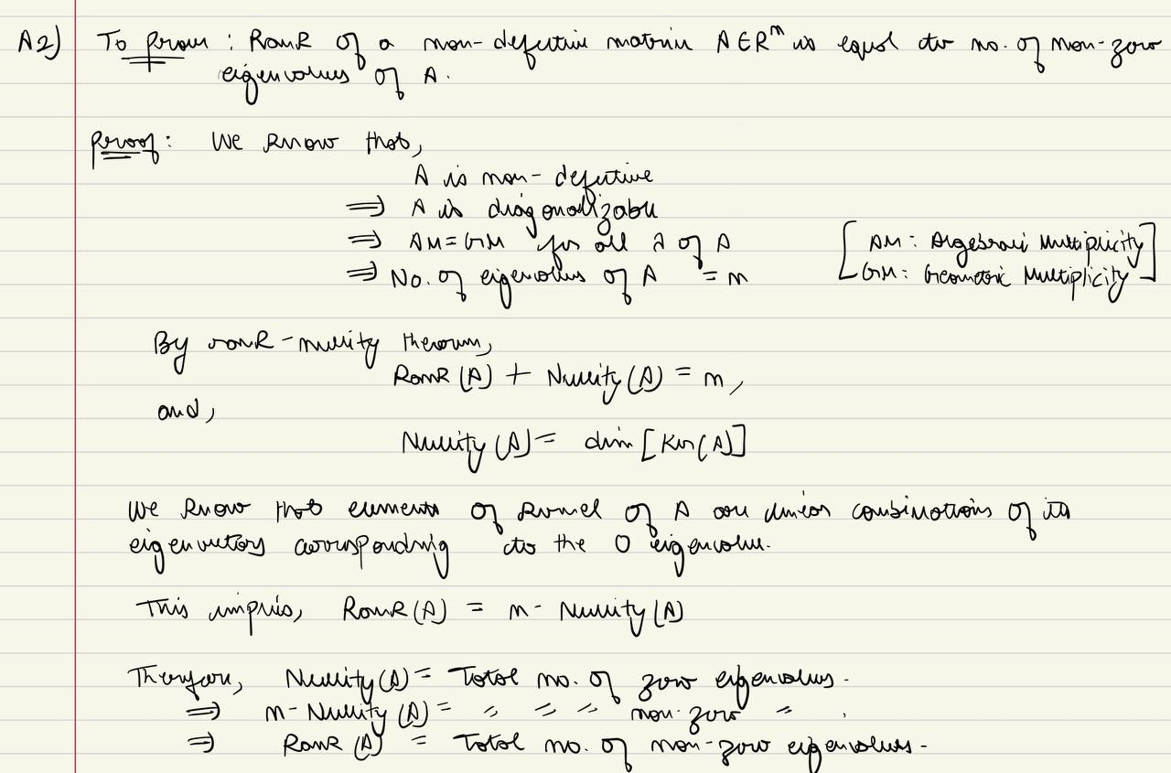

Problem – 3

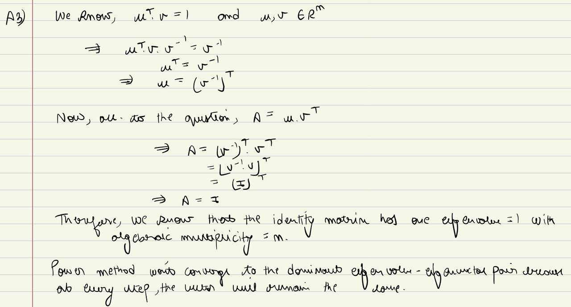

Problem – 4

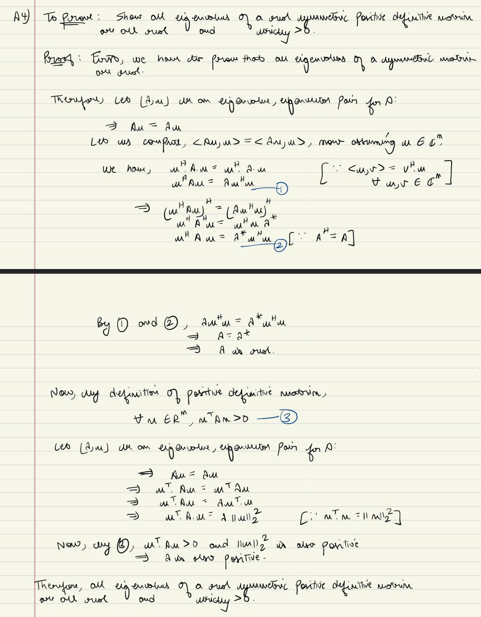

Problem – 5

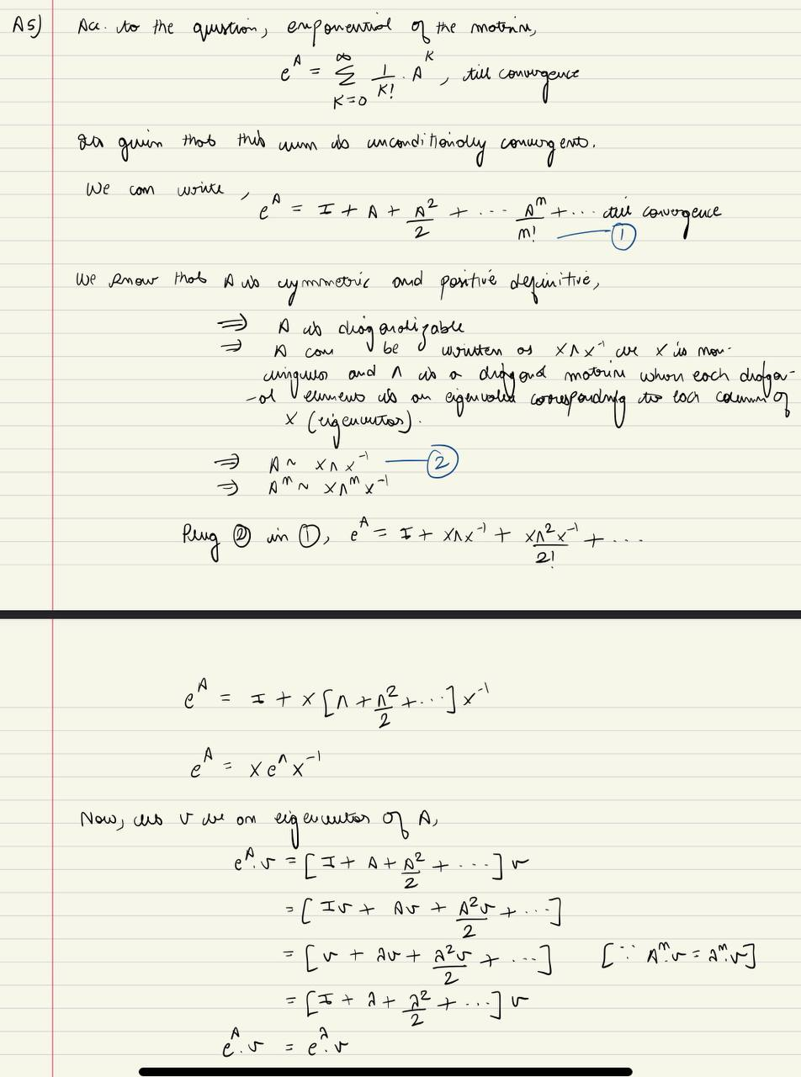

Problem – 6

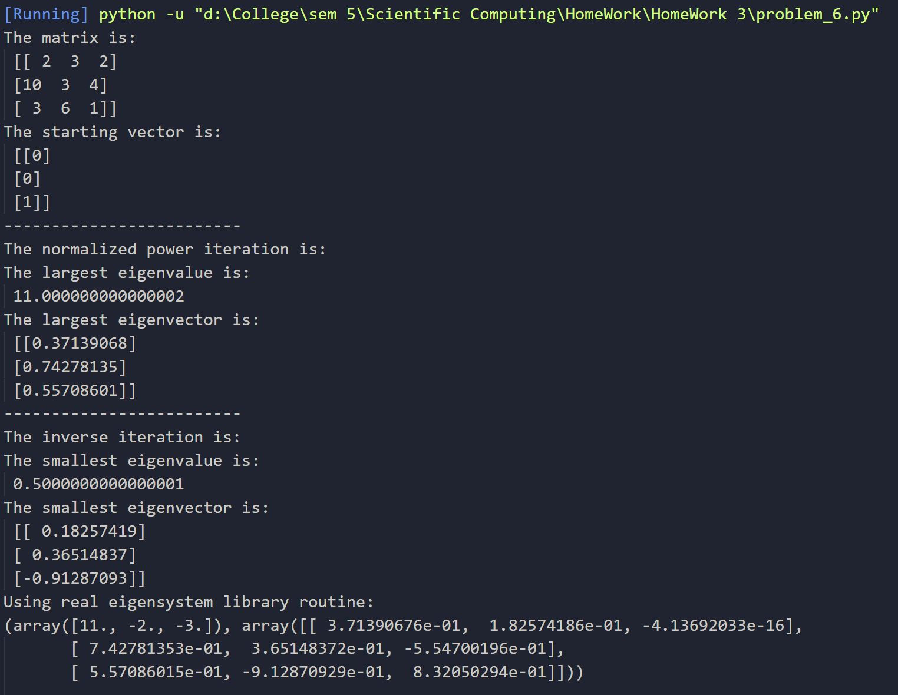

As we can clearly see in the output that the result for largest magnitude eigenvalue-eigenvector pair is same using normalized power iteration and using a general real eigenvalue library routine.

In the inverse iteration, values may differ from the library routine output because the inverse iteration that we implemented gives the smallest magnitude eigenvalue but the library gives smallest eigenvalue w.r.t sign i.e. –[Negative]

Problem –7

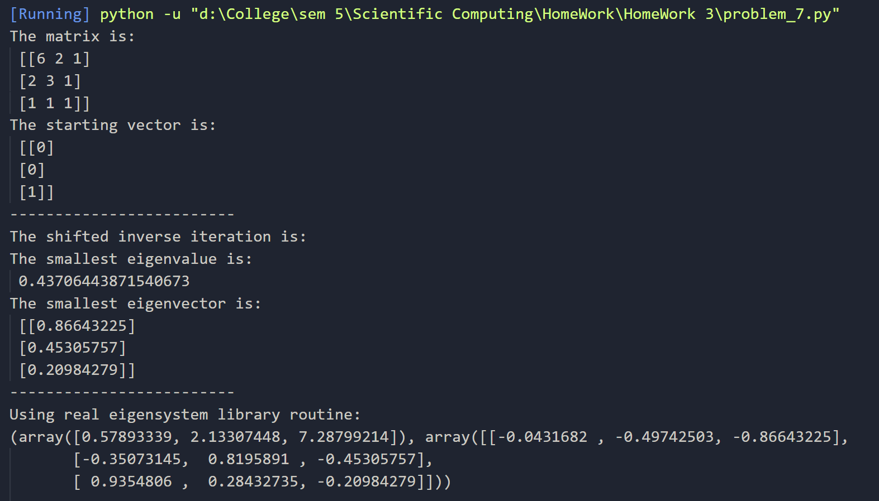

As we can clearly see in the output that the result for smallest magnitude eigenvalue-eigenvector pair using shifted inverse iteration with sigma = 5 and is close to the result generated using a general real eigenvalue library routine.

If we increase/decrease the value of sigma, the closeness of eigenvalue increases and eigenvector decreases and vice-versa.

The value may also be off due to the library routine handling error/edge cases and also handling rounding off errors which will occur in our implementation of shifted inverse.

Problem –8

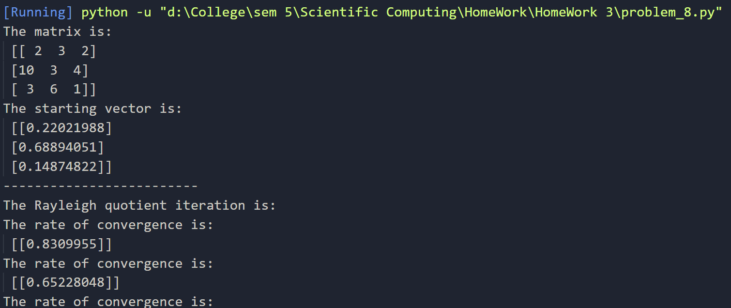

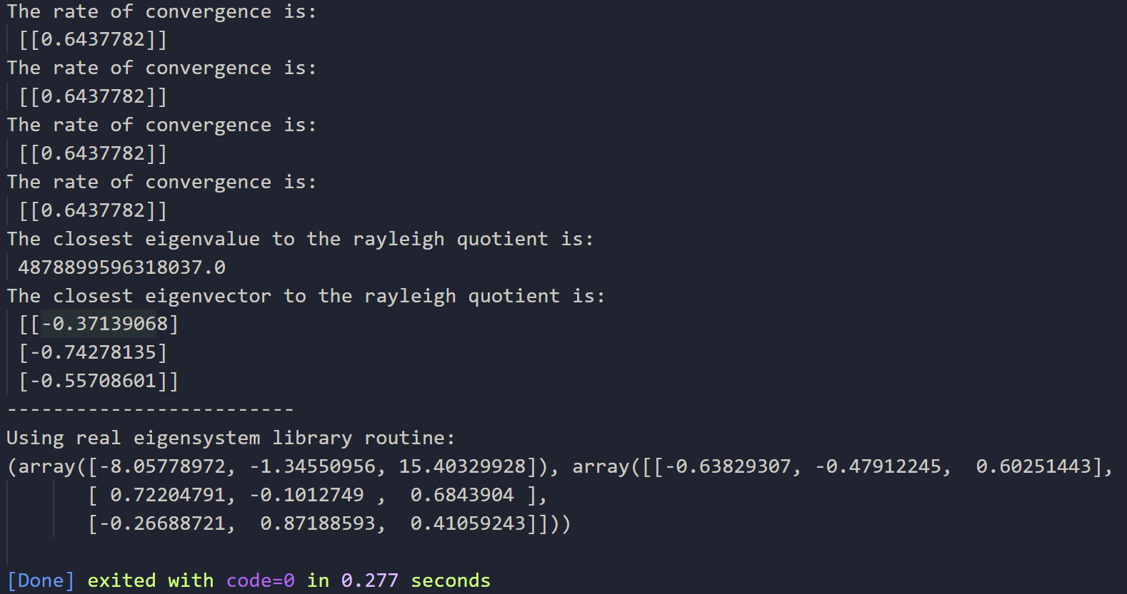

As we can see in the output that the result of our own coded Rayleigh Quotient Iteration of the eigenvalue-eigenvector pair is not equal to the one calculated by the real eigensystem library.

This is because that the library routine handled error/edge cases and also handles rounding off errors which will occur in our implementation of the same.

The rate of convergence is also calculated at every step.

Problem –9

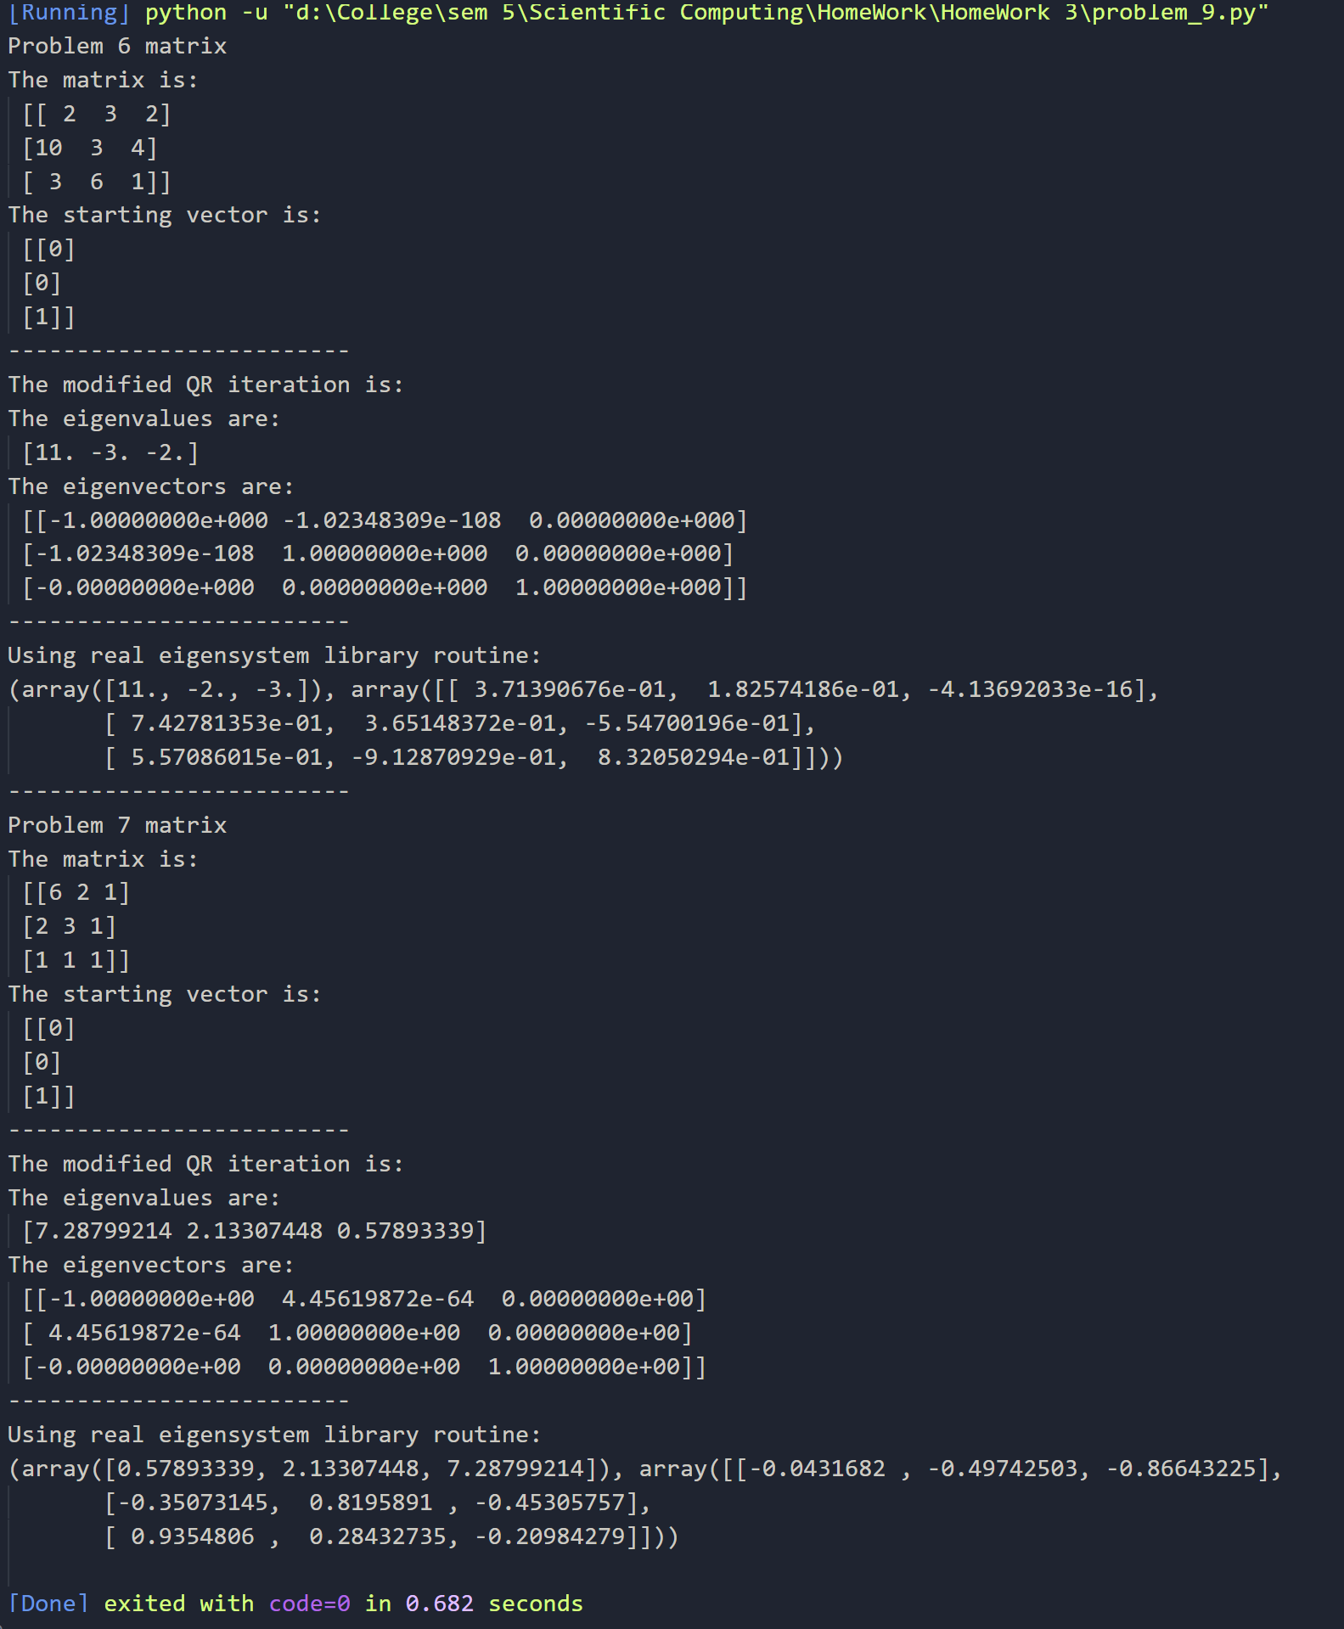

As we can clearly see in the output, the eigenvalue-eigenvector pair generated by modified QR iteration is exactly the same as the one given by the real eigensystem library routine.

This proves that modified QR iteration converges the fastest amongst all the methods and gives the most accurate result. The order of values may be different, but they are same.